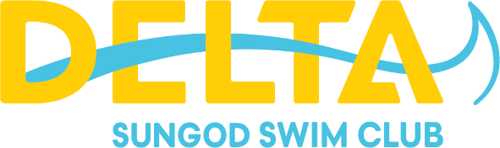

|  |
| --- |
| **Annual General Meeting** |
| Tuesday May 20, 2025 |
| 6:00-7:00pm – Sungod Arena Conference Room |
| Agenda |

1. Call to order
2. Acknowledgment of members present
3. Approval of the Agenda – May 20, 2025
4. Approval of the Minutes – April 15, 2024
5. Introduction of current board members
6. Reports
   1. Equipment Manager – Rachel Li
   2. Secretary/Registrar – Gavin Wang
   3. Officials Director – Kamaldeep Rai
   4. Volunteer Director – Laura Deeg
   5. Treasurer – Ian Naumenko
   6. President – Andy Lee
   7. Members-at-large – Michelle Johnson
   8. Head Coach – Kurt Murphy
7. Old Business
   1. Hiring a bookkeeper
8. Other Business
   1. Student Engagement
   2. Head Coach recruitment update
9. Appointment/Election of Board of Directors
   1. Confirm returning members: Laura Deeg, Andy Lee, Kamaldeep Rai, Ian Naumenko, Gavin Wang, Michelle Johnson
      1. Show of hands
   2. Elect new members:
      1. Submitted candidates
      2. Other candidates
10. Questions from the Membership
11. Adjournment